

American International University-Bangladesh (AIUB)

**Software Project 1**

**Chef Management System**

**Submitted By**

|  |  |
| --- | --- |
| 18-37693-1 | K.M. SAZZADUL ISLAM |
| 18-36686-1 | HEMAL MD. MEHEDI HASSAN |
| 18-36629-1 | AKTER RAJANA |
| 17-34565-2 | SALID SHADMAN |

**Department of Computer Science**

**Faculty of Science and Technology**

**American International University Bangladesh**

**August, 2021**

|  |
| --- |
| **Declaration** |

We declare that this project is our original work. No part of this has been submitted elsewhere partially or fully for the award of any other degree. Any material reproduced in this project has been properly acknowledged.

We declare that this project does not contain any content that discloses the secret of any organization or related parties. American International University-Bangladesh (AIUB) will not be held liable for any such activity, as the project is presented as our original work.

|  |  |
| --- | --- |
| _______________________________  **K.M. SAZZADUL ISLAM**  18-37693-1  Computer Science and Software Eng. | _______________________________  **HEMAL, MD MEHEDI HASSAN**  18-36686-1  Computer Science and Software Eng. |
|  |  |
| _______________________________  **SALID SHADMAN**  17-34565-2  Computer Science and Software Eng. | _______________________________  **AKTER RAJANA**  18-36629-1  Software Engineering |

|  |
| --- |
| **Approval** |

The thesis titled “Chef management system” has been submitted to the following respected members of the board of examiners of the department of computer science in partial fulfillment of the requirements for the degree of Bachelor of Science in Computer Science on (date of defense) and has been accepted as satisfactory.

|  |  |
| --- | --- |
| _______________________________  **M. Mahmudul Hasan**  Assistant Professor and Supervisor  Department of Computer Science  American International University-Bangladesh | _______________________________  **Md. Siyamul Islam**  Lecturer and External  Department of Computer Science  American International University-Bangladesh |
| _______________________________  **Dr. Mahbub Chowdhury Mishu** Head (Undergraduate Program) Department of Computer Science American International University-Bangladesh | _______________________________  **Professor Dr. Tafazzal Hossain** Dean Faculty of Science and Technology American International University-Bangladesh |
| _______________________________  **Dr. Carmen Z. Lamagna**  Vice Chancellor  American International University-Bangladesh | |

|  |
| --- |
| **Acknowledgement** |

This Project is our cordial effort and our supervisor’s initiative and constant motivation. But First of all, we would like to be grateful to the Almighty Allah, who gives us the effort to work on this project for the last one semester. Especially thanks goes to our honorable supervisor M. Mahmudul Hasan faculty member, American International University-Bangladesh [AIUB] for this enormous support, inspiration, and helpful criticism. His excellent supervision and constant support makes this project possible. We are very grateful to him for giving us the opportunity to work with him. We also convey our thanks to our honorable Vice Chancellor, Dr. Carmen Z. Lamagna, our Dean, Prof. Dr. Tafazzal Hossain, our Associate Dean, Mashiour Rahman, our Director, Dr. Dip Nandi, and our Head of Department, Dr. Mahbub Chowdhury Mishu for their constant motivation and support.

Last but not least we thank our respectable parents for educating us with aspect from both arts and sciences, for their unconditional support and encouragement to pursue out interests, even when interests went out of boundary.

**Table of Contents**

**Project Summary** 5

**Keywords** 6

**CHAPTER 1: INTRODUCTION** 7

**1.1** **Chef Management System** 7

**1.2** **Problem Analysis** 7

**1.3** **Project Motivation and Objective** 7

**1.4** **Literature Review of Existing studies** 8

**CHAPTER 2: RESEARCH METHODOLOGY** 10

**2.1 Conceptual Framework** 10

**2.2** **Data Collection Method** 13

**2.3** **Ethical Issue** 16

**CHAPTER 3: PROJECT PLAN** 17

**3.1 Project/Thesis Effort Estimation** 17

**3.3** **Uncertainties and Risk Analysis** 20

**3.4 Project Execution** 21

**CHAPTER 4: RESULTS AND ANALYSIS** 22

**4.1** **Solution Description** 22

**4.1.2 Functional Requirement** 22

**4.1.3 Non-Functional Requirement** 25

**4.2 Impact on Environment:** 34

**4.3 Lifecycle Analysis** 34

**4.4 Solution Verification** 35

**CONCLUSION** 40

**REFERENCE** 40

**APPENDIX** 41

# **Project Summary**

This project is about the Chef management system. This is a web-based project. The focus of the paper is to study software engineering used for making Chef management systems using SCRUM project management framework. In SCRUM, projects move forward via a series of iterations and sprints. Each sprint is typically two to four weeks long. Right now, people need chefs for their family programs or other occasional programs, but it is hard to find a perfect chef. Sometimes chefs demand too much, which is unfair. Users can easily book any chef for their favorite dish. They can pay via card, bkash and any banking method. In our project, we will try to solve those problems. We will make a website where users can reserve chefs as they need. The chef management system will make this system digitalize. This project objective is to reduce the difficulty of finding chefs and fair prices for chefs. This is a big project. We will divide the project into two parts. First, we have to work on its front-end then second part we have to work on its backend. In the front-end we have to design UI/UX then we need to implement that UI/UX in HTML CSS format. In the second part, we need to work on the backend, in the backend we will use PHP and JS. If we want we can test this web site. To implement this software in this project will use the SCRUM model. To estimate the cost time will use the COCOMO model. We will collect our data via survey. The result will be discourse in this project after getting all the data. If we implement the system in the future we will test every operation and check the result. To test our project we will use selenium. We will test every module with selenium test automation tool. Selenium is a portable framework for testing web applications. Selenium provides a playback tool for authoring functional tests without the need to learn a test scripting language.

# **Keywords**

Chef management system, UI/UX, HTML, PHP, Java Script, SCRUM, COCOMO.

# **CHAPTER 1: INTRODUCTION**

# **Chef Management System**

The chef management system is a system through which people can hire a chef just by sitting at home, with a click. This system includes usernames/passwords, following that people will give their budgets and other required information for a chef to confirm. After a chef confirms within the many, the user will have to pay the money digitally. Through this process, the problem of cooking in bulk will be solved like if any guests come over, they can just solve the problem of cooking easily. Users can easily book any chef for their favorite dish. They can pay via card, bkash, nagad and any banking method.

**References**

1)V. A. Bharadi,(2013) Intelligent e-Restaurant using Android OS, Mumbai.

2)M. Rajesh,(2015) "E-Restaurant: Online Restaurant Management", *India: International Journal & Magazine of Engineering*.

# **Problem Analysis**

The main objective of this project is to help those people who don’t know how to cook properly or are not skilled in cooking. Also, if someone knows how to cook but due to a huge amount of guests he/she can’t cook on their own and needs an expert hand to cook. So, with the help of our software he/she can easily hire a chef. Our solution is particularly appropriate to solve the problem because if anyone doesn't want to order foods from outside but wants to cook in house, without our given solution it’s not possible to achieve. And obviously this solution is feasible to meet the business objective.

There are a lot of causes to consider, but one to highlight is the problem of cooking for guests in mass quantities .This is a problem people face very often. Whenever there is an occasion or program, many might feel it is a problem to cook so through this system it will easily enable them to solve this cooking issue. The software is specified under online chef business and its purpose is to serve people who are not skilled in cooking or need a chef. The benefits of this software are likely for chefs, those who don’t like outside foods also can’t cook in house but need a chef to cook for him/her. The goal of this project is to solve or help people who don’t know how to cook or are not skilled in cooking.

# **Project Motivation and Objective**

Most of the time we saw many types of systems which are similar to this system such as kitchen management system, Food management system, cooking management system, restaurant management system, online food delivery system etc. Both of these systems describe the quality of food, the price of the dishes, the making criteria of the food, availability of the food, the test review of the food etc. But if we arrange a small party and we order food using any online food delivery system or go to the restaurant then we face some problem most of the time. Like the availability problem, which food we need, we don’t know the food test, food is not delivered in time and so on. Here why not create a system which would provide us a chef to solve that kind of problem. If there was an application which provided us a chef who was near us then we could easily hire them to cook the item which we want. As a result, we serve the food to the guest in time and get all the food items which we have selected. That’s why we want to build a chef management system software which helps to solve those kinds of problems which were discussed previously.

Our project objective is to provide a chef and help the users to throw a tension free party. There users find the chef details, which kinds of dishes a chef avail to make, the availability time of the chef, the location of the chef, the payment method details etc. A user can easily find near the chef details and review, it helps the user to choose the chef and avail contact with the chef. They can be available to choose the food types and payment method also. Here we provide cash on hand payment method and also online payment method (Bkash, Nagad etc.). As a result, the user can’t face any problem paying the payment. They use any kind of payment method which is suitable for them. Our target group of users are those users who arranged a home party program where 20-30 people are present. If they use this app then they easily solve the problems which were discussed previously.

# **Literature Review of Existing studies**

In this project, we saw that those people who don’t know how to cook properly or are not skilled in cooking Also if someone knows how to cook but due to a huge number of guests, then there are some people who like pure food and there are some people who like dishes from different countries. But if there are more guests, they cannot manage these dishes. These problems are the biggest problems. So that’s why we have come up with a software that can solve these problems. If the user thinks that cooking will be difficult for many guests, then they can easily get rid of this problem by using our system, we will provide chef in this system according to the user's needs. Not only this, but the user can also tell what kind of food they want for the guest which is in their mind. The user can easily get a chef by using our proposed system, without any harassment. Users will be able to make online payments which is free from all hassles

We have seen that no similar project has been done so far. But based on other systems that have some similarities, it can be said that the current system is paper based. Papers are used in restaurants to display traditional menu cards, note customer orders, and store customer records. The disadvantage of paper-based systems is that papers can be easily damaged by stains; they may be lost by fire or accident or may be lost in general. As a result, time and money are wasted. Since traditional menu cards are paper based, any changes that need to be made to the menu will require reprinting the entire menu card, resulting in waste. For minor changes, it is not possible to reprint the entire menu card. Changes to menu tags cannot be made automatically. Accessing a specific record from the stack is inefficient. This system consumes time. You have to call a waiter over and over again until he realizes it and wait for him to come to their table to take the order. In addition, the waiter may misinterpret the customer's order as he writes the order down on paper, and in the case of serving the wrong dish

Existing programs offer an app that restaurants can use to make their menus available to iOS and Android tablets, and make it easier for diners to flip, swipe, and tap the menu. We will provide a software in which the user will like the chef according to their rating. We will provide that chef through the system and will be able to choose dishes from different countries. Proposed system consists of the following modules.

**MODULES**

**Module 1: Login Module**

In the login module the user/chef and login will be taken while they are already registered on the application. Every chef/user will have a login id and password to login to the application.

**Module 2: Registration Module**

This module is displayed to the visitors if they need to perform order chef and new registration for chef management system and who wants to do business with us (chef) on our chef management system.

**Module 3: Add/Update/remove Menu**

This module is for admin. Admin have rights to insert, update (modify) and delete the data in the database as per his/her necessary requirements.

**Module 6: Carting Module**

This is additional feature given to add the food items in customers virtual basket just like pending orders the orders which customer wants to do later. But, if the customer is first time visiting then he/she will be unable to place order until he/she does registration for our application.

**Module 7: Logout Module**

The last module describes that after placing order or performing some actions on the application the customer will click the logout profile.

# **CHAPTER 2: RESEARCH METHODOLOGY**

# **2.1 Conceptual Framework**

We selected the SCRUM model for our project. Scrumis the most widely used Agile methodology. Scrum refers to a system that allows groups working on complicated items to collaborate effectively. Despite the fact that it is most commonly used by program improvement teams, scrum can be advantageous to any group that is working toward a similar goal. Scrum can be defined as a collection of gatherings, components, and instruments that work together to assist groups to superior structure and oversee their workload.

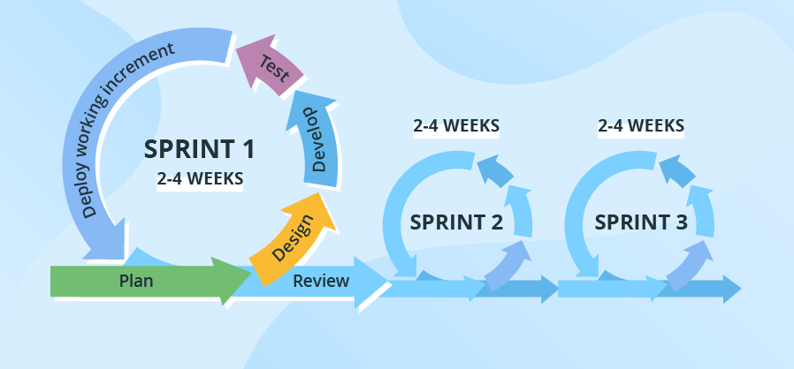

Figure 1: SCRUM Process

**Benefits of the Scrum Model:**

1. Scrum is probably the most popular Agile model.
2. Scrum can assist teams in completing project deliverables in a timely and efficient manner.
3. Scrum ensures that time and money are spent wisely.
4. Large projects are broken down into smaller, more manageable sprints.
5. During the sprint review, new features are coded and tested.
6. Scrum meetings provide the team with clear visibility.
7. Short sprints make it much easier to make project adjustments based on feedback.
8. During daily Scrum meetings, each team member's unique effort is evident.

**Why choose the Scrum model**

We chose the Scrum model. Scrum is one of the popular models right now. At first the client gave a requirement. As per that requirement, the team will divide this project in different sections. Then the team will start the work from the 1st section. After completing each section, the team will talk with the client and take a confirmation from the client, after this confirmation team will move to the second section. If there is any kind of objection from the client then teams will fix this fast. As a result this project will be a totally complete project from a client perspective. Also, no mash at the end from developer perspective. The Scrum model has another benefit is it has time flexibility. At first the team fixed a time but if there was any kind of time difficulty then developers could fix that time with other sections. So, there is no issue with managing time.

**Scrum model in our project**

Collecting requirements for a project is the most vital part of a project. The process of gathering requirements aids us in defining project scope and obtaining the desired outcome.

1. Functional requirements.
2. Nonfunctional requirements.

The software's functionality, such as its capabilities, usability, features, and operations, is directly tied to functional requirements. In the Requirement section of our project, we will explicitly explain the functional requirements. Non-functional requirements have nothing to do with the software's performance, stability, security, or technical specifications. In the Requirement section of our project, we shall explicitly outline non-functional requirements.

The most important part of the software development process is software design. The actual architecture of a software is created during the design phase. We will design the activity diagram, use case diagram, entity-relationship diagram and class diagram in the design phase of our project. We will also design the user interface to highlight the structural part of our application development.

**Activity Diagram for Admin:**

There is a login page for the admin. Admins must first login and authenticate, after which they will be redirected to the control admin dashboard. Admin may manage User order and payment, Employee activity, Product Category and other things via the admin dashboard. Admins can also Update Schedule to this dashboard.

**Activity Diagram for Users:**

There is a Registration and login page for the User. Users must first Register and validate in then login and authenticate, after which they will be redirected to the control place order. Users may manage Schedule Making, Payment and View Invoice. Users can also Edit and Update their profile and personal information.

**Use case diagram:**

In this diagram we can see four characters: User, Chef, Admin, and system. User and Admin both can visit the login page. The User can also visit the registration page. Users can also make schedules; they can select food items and also select chefs. Users must confirm his/her order. After confirming the order, the system gives a confirmation message to User. The chef only views his/her order. Admin may manage add admin, view all orders, cancel order, payment list check and update schedule to system.

**ER Diagram:**

Actually, this diagram represents a database. ER diagram is a visual copy of the database. Here we select many entities like User, Admin, Chef, Food, Payment, and Invoice. All of those have a key attribute. There are relations between entities.

**Class Diagram:**

The relationships between classes are depicted in this diagram. There are classes for admin, customer, chef, and food item, payment as well as variables, public data types, and methods/functions. An id is an Integer data type with a default value in the admin class, and it has methods like addUser() and others. Customers also have variables and functions with default values. Also, the user class has a connection to the payment classes.

**Database:**

Database is a very important part for any kind of software and web site. Because without data they can’t do anything. A lot of data needs to be stored in the database. At our database we need User, Admin, Chef, Food and Payment tables. Those tables have a relationship with each other.

**User Interface**

**Login Page:**

Through this page users can login. Here users need to fill up their email and password. If they are valid then the users can order and pay.

**Registration Page:**

Through this page users can register themselves. Here users need to fill up their name, email, phone, and password. Then they will be authenticated to our server and accepted for login as well.

**Home Page:**

This page shows our details. Users can visit everywhere from the nav bar and also can search chef from the search box. Through this page users have to Register and login.

**Admin Dashboard:**

This page is only for admin. Admin can use this page only for upload, delete and edit chef details. Also, one admin can add another admin and see other admins.

# **Data Collection Method**

The main tool for gaining primary information in practical research is questionnaires, due to the fact that the researcher can decide on the sample and the types of questions to be asked. In this survey questions, each respondent is requested to reply to an identical list of questions mixed so that business was prevented. Initially the questionnaire design was coded and mixed up from specific topic based on uniform structures. Consequently, the questionnaire produced valuable data which was required to achieve the dissertation objectives. This questionnaire is given below-

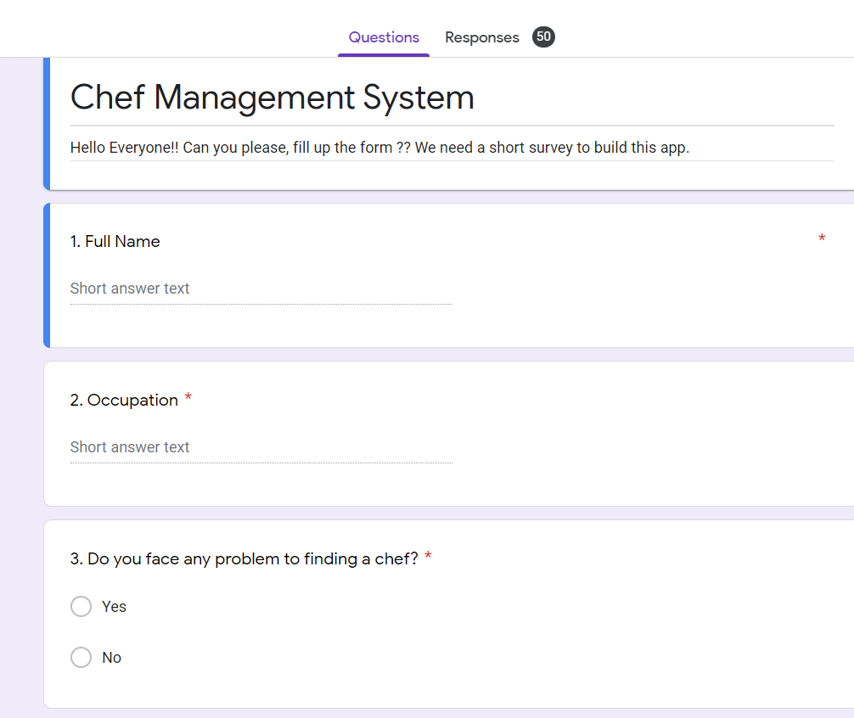

Figure 2: Survey questionnaire (1)

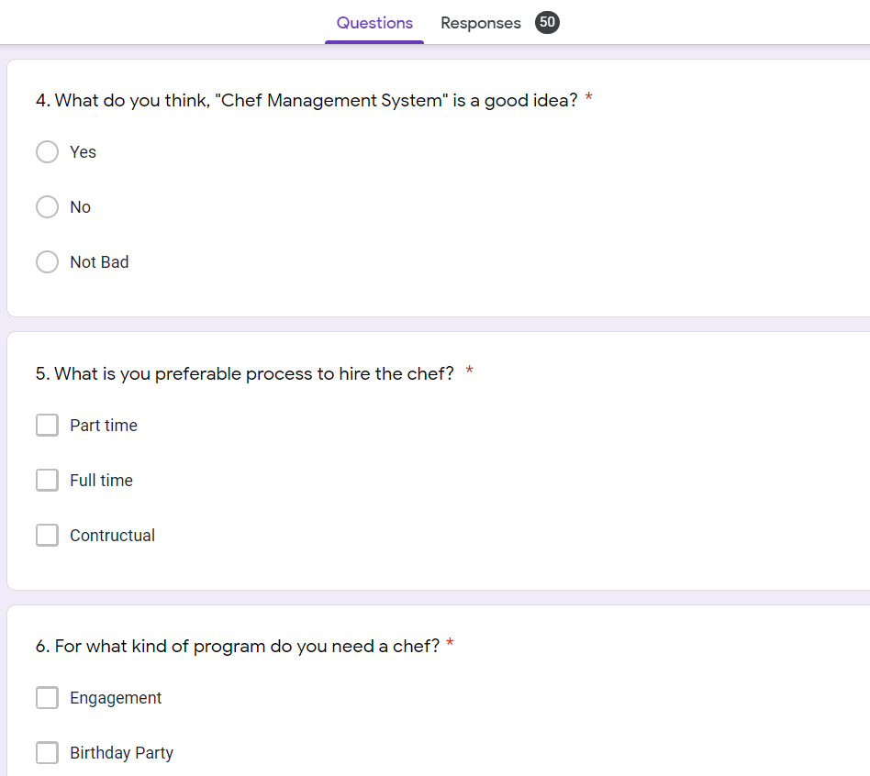

Figure 3: Survey questionnaire (2)

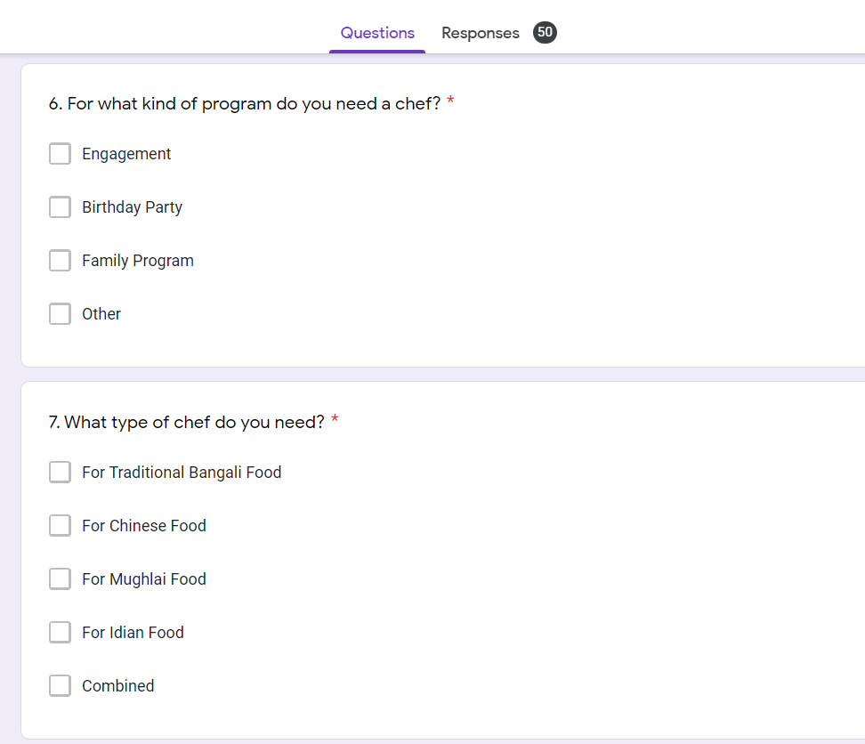

Figure 4: Survey questionnaire (3)

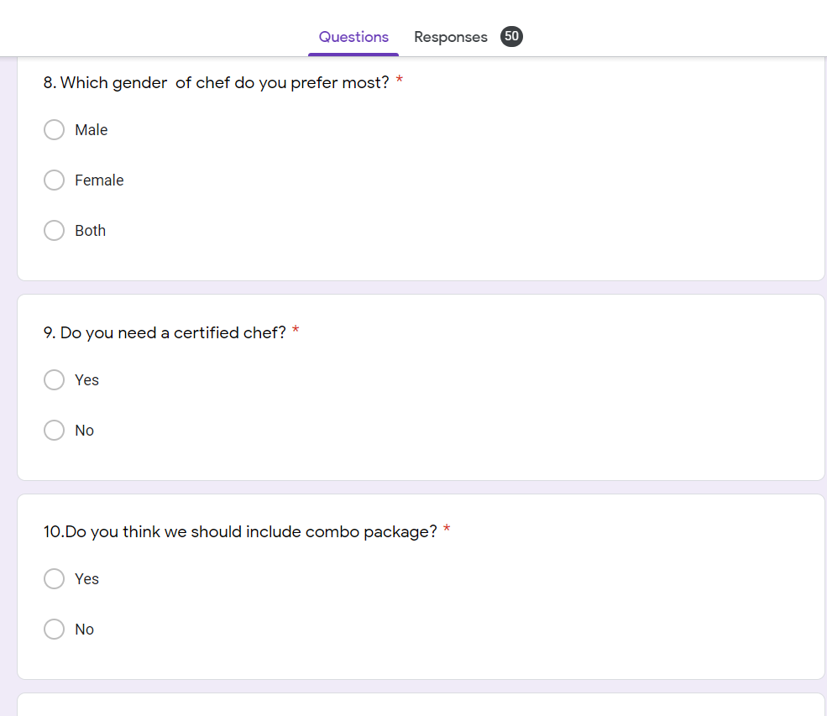

Figure 5: Survey questionnaire (4)

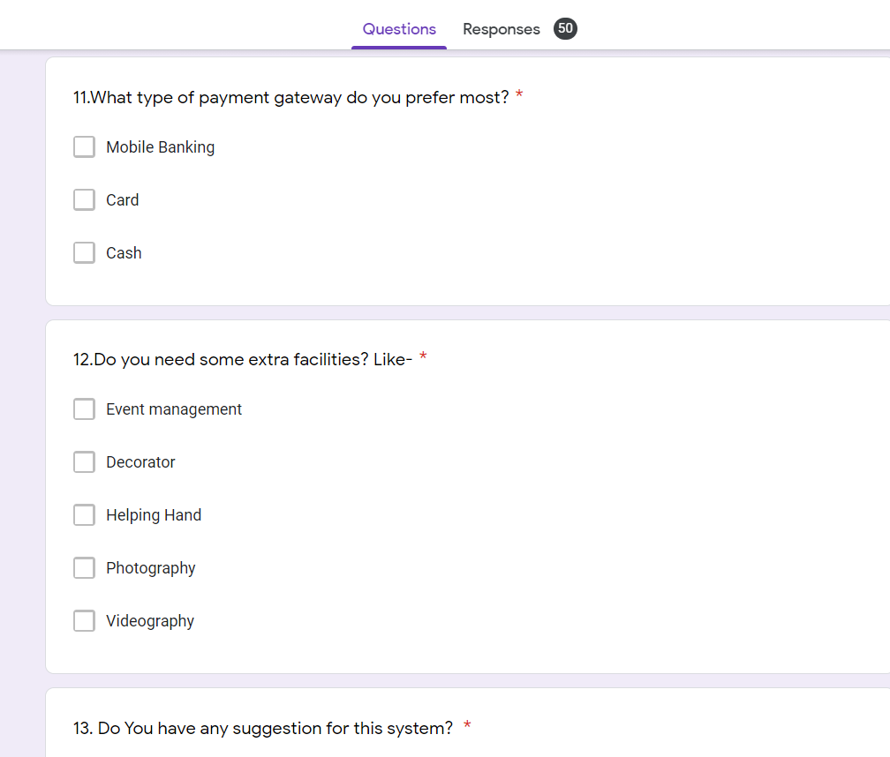

Figure 6: Survey questionnaire (5)

In those questionnaires we have found how people face problems most of the time to find out their chef. As a result, we built the app to solve those problems which people face all time to find a chef. And we also built up that type of app with some extra features.

# **Ethical Issue**

We need to keep some ethics in mind when working on software projects. They must develop various appropriate data collection methods, analyze the dataset, and design the dataset based on the report's requirements in order to prepare a report for which they must develop various appropriate data collection methods, analyze the dataset, and design the dataset based on the report's requirements in order to prepare a report for which they must develop various appropriate data collection methods, analyze the dataset, and design the dataset based on the report's requirements. So that they can fulfill their objectives, the team members should be aware of any ethical issues that may occur during the research. For data gathering systems, we choose online questionnaires. To eliminate bias, the questions should be properly crafted and should not be biased or misleading.

We attempted to avoid data fabrication by establishing survey research in order to obtain real data from a variety of people. The material is not plagiarized because we did not obtain and duplicate it from other sources. Instead, we gathered realistic data from reliable sources in order to make the study more realistic. Another important fact of ethical issues is the possibility of conflicts of interest among team members when conducting research together. We have avoided disputes of any kind, whether personal, political, or otherwise.

# **CHAPTER 3: PROJECT PLAN**

# **3.1 Project/Thesis Effort Estimation**

We must estimate the work, development time, and cost of our project in order to develop it. As a result, we decided to estimate our project using the Constructive Cost Model (COCOMO).

We determine the inputs, outputs, file access, and interfaces to an external system after accurately gathering the requirements and decomposing the functions. In this part we will use the Basic model. We will use an organic model here.

We know, For Organic model-

a= 2.4, b= 1.05, c= 2.5, d=0.38

We assume-

SLOC= 9000

KLOC= = 9

**Effort Required:**

E=

=

=24.12 24

**Time Required:**

Time =

=

= 8.36 8 Weeks

**Person required** =

=

= 3 person

**Budget Breakdown:**

|  |  |
| --- | --- |
| **Description** | **Cost** |
| Site Developers | 1500$ |
| Domain & Hosting | 600$ |
| Maintenance (1 year) | 800$ |
| **Total** | **2900$** |

**3.2 Project Work Break down**

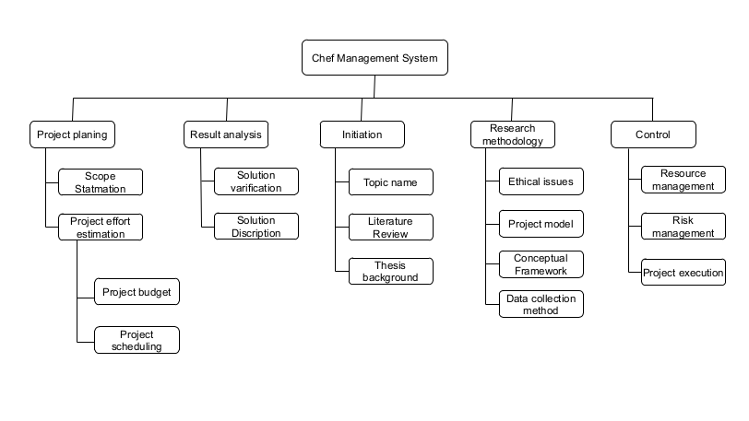

Figure 7: Work break down (WBS) of the project

**Task 1**

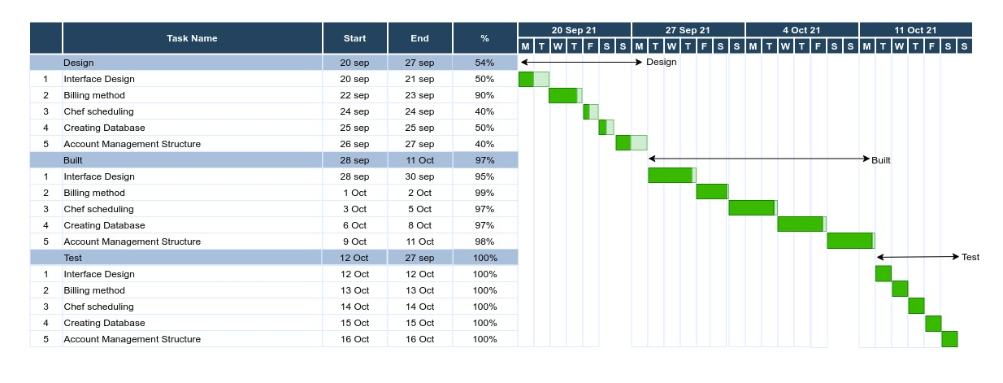

Figure 8: Project Scheduling (1)

**Task 2**

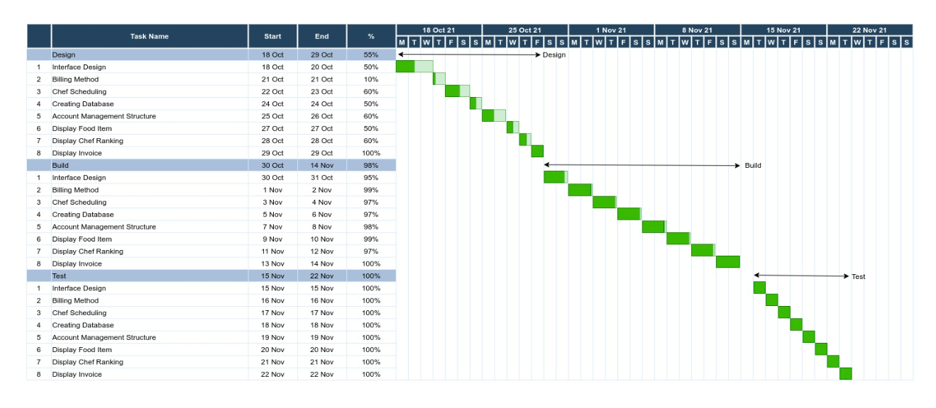

Figure 9: Project Scheduling (2)

**Task 3**

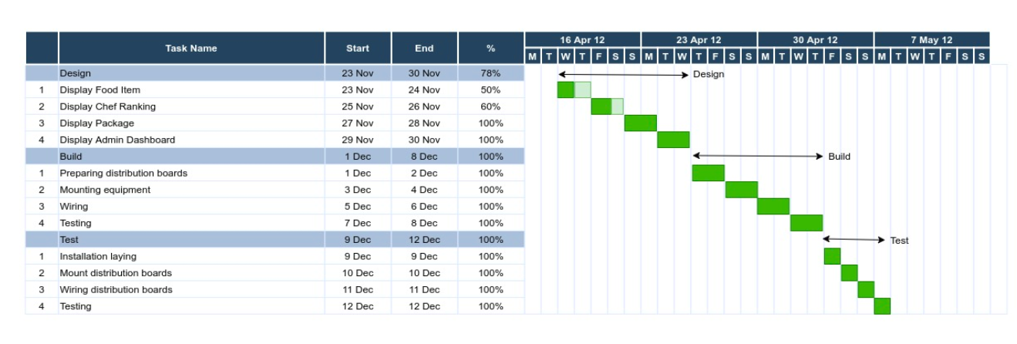

Figure 10: Project Scheduling (3)

# **Uncertainties and Risk Analysis**

|  |  |  |  |  |
| --- | --- | --- | --- | --- |
| **S/N** | **Risk Description** | **Probability** | **Impact** | **Mitigation Plan** |
| 1 | Unrealistic time estimate | 40% | Significant | Take multiple estimation |
| 2 | Budget Risk | 40% | Significant | To avoid such ambiguities, everyone should examine the external as well as internal variables that block the project's functioning and set aside cash to cope with a problem that may develop in the near future. |
| 3 | Communication Issue | 40% | Significant | Schedule team meeting properly, Focus on team combination |
| 4 | Technology Risk | 50% | High | Use stable OS, Keep backup device, |
| 5 | Resource Risk | 30% | Low | Collect more resources, Consulting with team members |
| 6 | Health Issue | 70% | High | Overtime teamwork, Proxy by reserve team members |
| 7 | Environment Issue | 60% | High | Recruit experienced members |
| 8 | Miscellaneous Risk | 20% | Low | Take extra precautions |

# 

# **3.4 Project Execution**

**For Project Deliverable**

|  |  |  |  |  |  |
| --- | --- | --- | --- | --- | --- |
| **Phases** | **Task** | **Lead** | **Start** | **End** | **Workday** |
| 1 | Preliminary Project plan | K.M Sazzadul Islam | 2021-05-06 | 2021-05-12 | 06 |
| 2 | Requirements Specification | Sadman Salid | 2021-05-13 | 2021-05-19 | 06 |
| 3 | Analysis [Object model, User interface] | Rejana akter | 2021-05-20 | 2021-05-25 | 05 |
| 4 | UI/UX | K.M Sazzadul Islam | 2021-05-26 | 20-05-31 | 04 |
| 5 | Frontend | Sadman Salid | 2021-06-01 | 2021-06--15 | 14 |
| 6 | Backend | Hemal Hassen | 2021-06-16 | 2021-06-30 | 14 |
| 7 | Test plan | Rejana Akter | 2021-07-1 | 2021-07-20 | 19 |
| 8 | Final product | Hemal Hassan | 2021-07-21 | 2021-07-23 | 02 |

# **CHAPTER 4: RESULTS AND ANALYSIS**

# **Solution Description**

We are going to make a software called “Chef Management System” where people can hire chefs for their program and chefs also can get a chance to work. Users can simply use the online platform or download the app in Google play store and let Chef Management System to help them get their program easily done. When a user makes a request, all the related verified chefs in the relevant area are notified of their offers. Users thereafter receive offers from these trusted chefs and go on to choose the person for the program. Users can request for instant service and also can request for day-based work.

This solution is perfect to solve the problem because the user can hire an instant chef by a trusted source and the user doesn't need to look for a chef in a restaurant. Sometimes people don’t even know whom to contact when there is an emergency need for a chef. There are lots of benefits to using an online chef management system. Such as-time saving, cost savings, getting quality service, punctuality, reducing stress etc.

# **4.1.2 Functional Requirement**

Functional requirements describe what we should do and what the user expects from the fully developed system.

1. **User Registration:**
   1. Users need to register to the system with their valid information.
   2. One user can register one time with their phone number.
   3. User ID will be generated automatically from the database.

**Priority Level:** High **Precondition:** User phone number must be unique.

**Cross-references:** 4.1

1. **User Login:**

* 1. The Web system shall allow users to login with their given phone no and password.
  2. The login credentials (Phone no and password) will be verified with database records.
  3. If the login is successful the home page of the user account will be displayed.
  4. If the username and/or password has been inserted wrong, the random verification code will be generated and sent to the user’s email address by the system to retry login.
  5. If the user forgot the password, there will be an option which will help to recover the password.

**Priority Level:** High **Precondition:** user have valid user id, E-mail address and password  
**Cross-references:** 4.1

1. **Chef Login:**

* 1. The Web system shall allow chefs to login with admin given phone no and password.
  2. The login credentials (phone no and password) will be verified with database records.
  3. If the login is successful the home page of the user account will be displayed.
  4. After login the system chef can see his schedule and order list.

**Priority Level:** High **Precondition:** user have valid user id and password  
**Cross-references:** 4.1

1. **User Profile:**

* 1. If users log in with a valid user id and password, they can see their profile from the home page.
  2. Customers can update their profile by giving a valid password.
  3. Users can upload a profile picture.
  4. Chefs can cancel their order within 1 hours. After 1 hours those order automatically accepted.

**Priority Level:** High **Precondition:** User have valid information of mobile number, E-mail address, NID

**Cross-references:** 4.1

1. **Admin:**

* 1. Admin can maintain a schedule.
  2. Admin can add another admin.
  3. Admin can add chef and chef schedule.
  4. Admin can edit package and chef details.
  5. Admin can see the payment invoice.
  6. Admin can see customer details and chef.

**Priority Level:** High **Precondition:** user have valid user id and password  
**Cross-references:** 4.1

1. **Chef:**

* 1. Chef can see the order list.
  2. Chef can see the schedule list.

**Priority Level:** Medium **Precondition:** user have valid user id and password

**Cross-references:** 4.1

1. **Online Payment:**
   1. User (who will receive the service) shall be able to pay online

**Priority Level:** Medium **Precondition:** user have valid user id and password  
**Cross-references:** 4.1

1. **Search Function:**

* 1. User shall be able to search chef using search function
  2. User shall be able to search package using search function

**Priority Level:** High **Precondition:** Not required  
**Cross-references:** 4.1

1. **Chef Rating system:**
   1. User shall rate the worker after getting the service

**Priority Level:** Law **Precondition:** Not required  
**Cross-references:** 4.1

# **4.1.3 Non-Functional Requirement**

1. **Performance:**

* 1. Web pages change time within three seconds.
  2. One thousand users can use the system at a time.

**Priority Level:** High **Precondition:** Not required

**Cross-references:** 4.1

1. **Useability:**

* 1. Users have to complete all the tasks of the software by themselves.
  2. The system will give any result with error free.

**Priority Level:** High **Precondition:** Not required

**Cross-references:** 4.1

1. **Maintainability:**

* 1. Normally the admin can maintain the page.
  2. One dedicated team will always work for the system upgrade.

**Priority Level:** High **Precondition:** user have valid user id and password  
**Cross-references:** 4.1

1. **Integrity:**

* 1. The system shall have SSL (Secure Socket Layer) certificate and shall have back up with proper authentication.

**Priority Level:** High **Precondition:** Not required

**Cross-references:** 4.1

1. **Availability:**

* 1. The system will service 24/7 hours.

**Priority Level:** High **Precondition:** Not required

**Cross-references:** 4.1

1. **Scalability:**

* 1. System shall be optimized for more traffics and shall have the operational capabilities to meet the user demand

**Priority Level:** High **Precondition:** Not required

**Cross-references:** 4.1

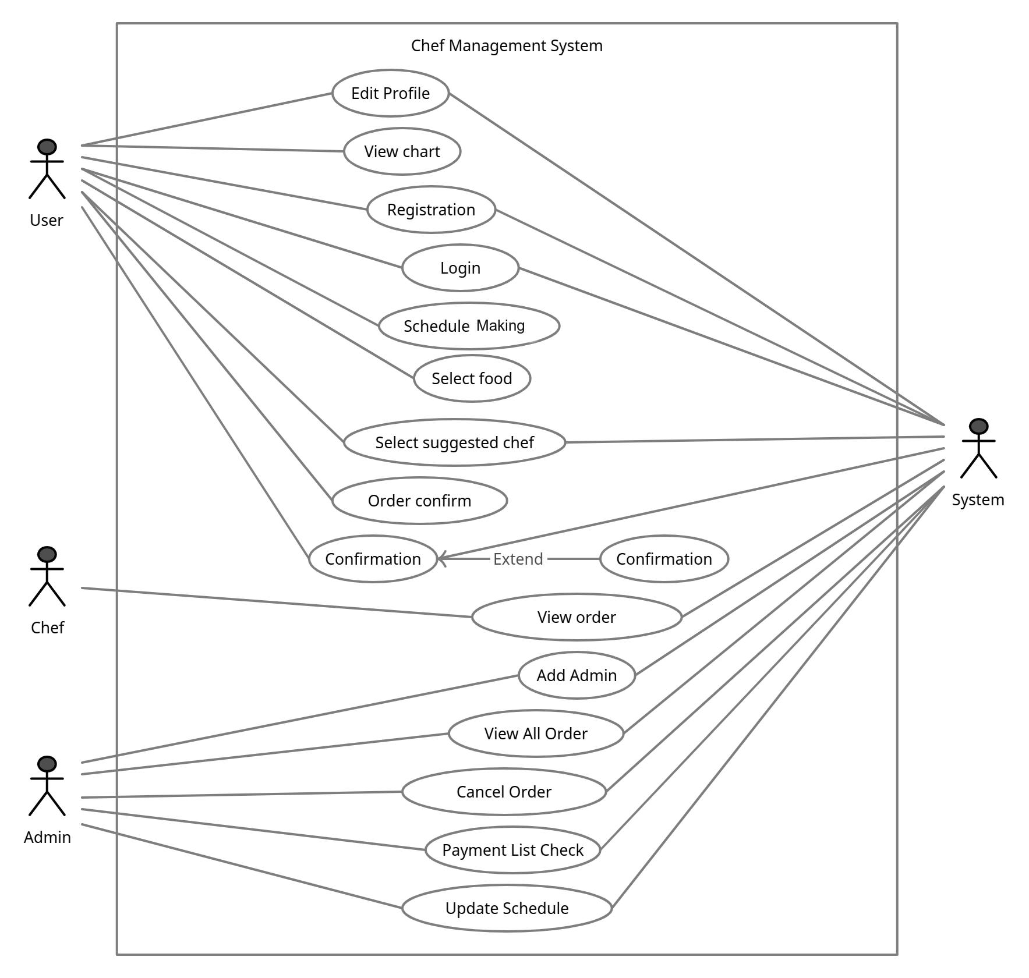

Figure 11: Use case diagram of the system

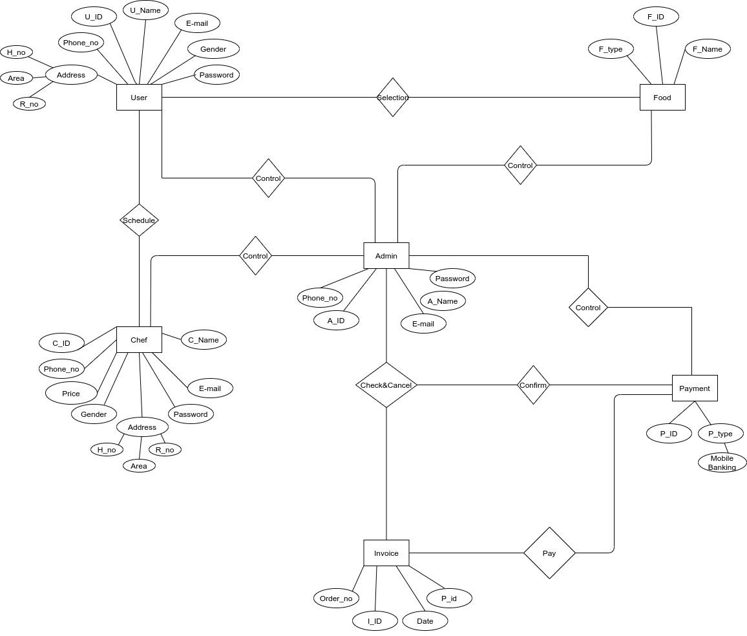

Figure 12: E-R diagram of the system

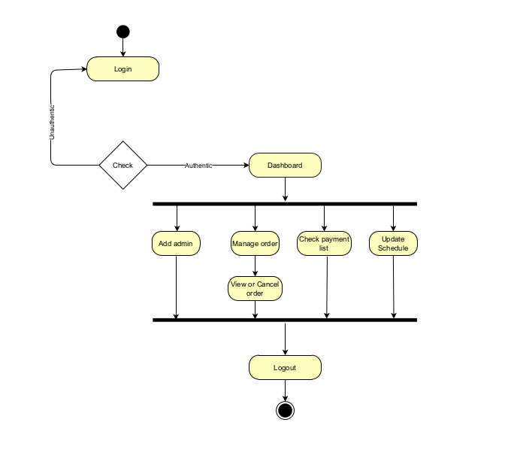

Figure 13: Activity diagram of the system for Admin use

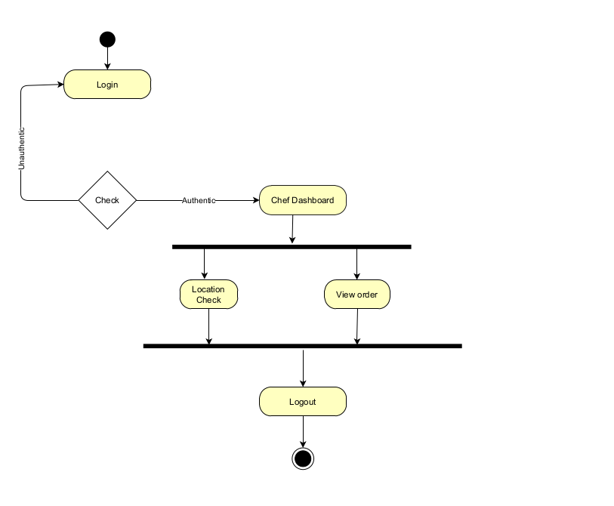

Figure 14: Activity diagram of the system for Chef use

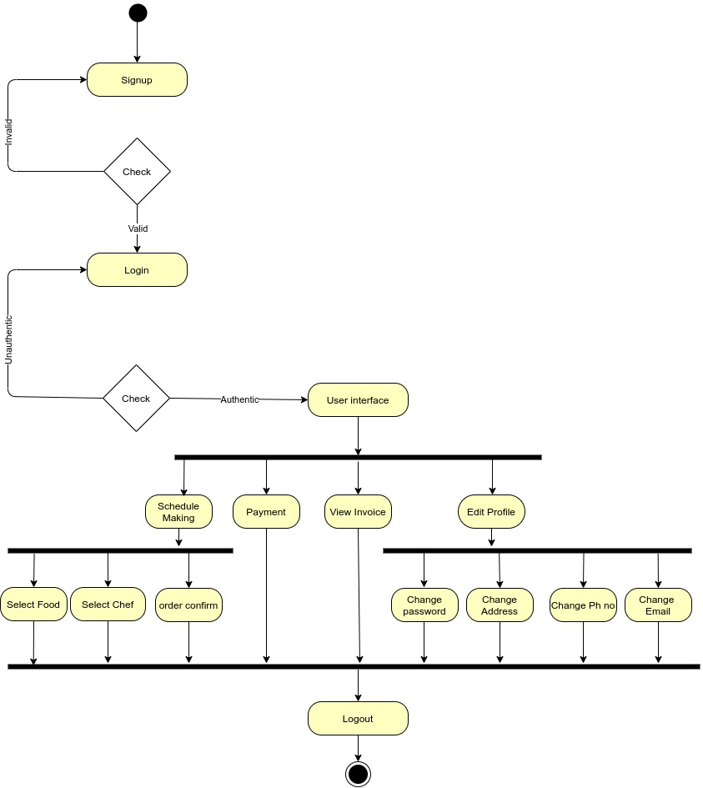

Figure 15: Activity diagram of the system for User use

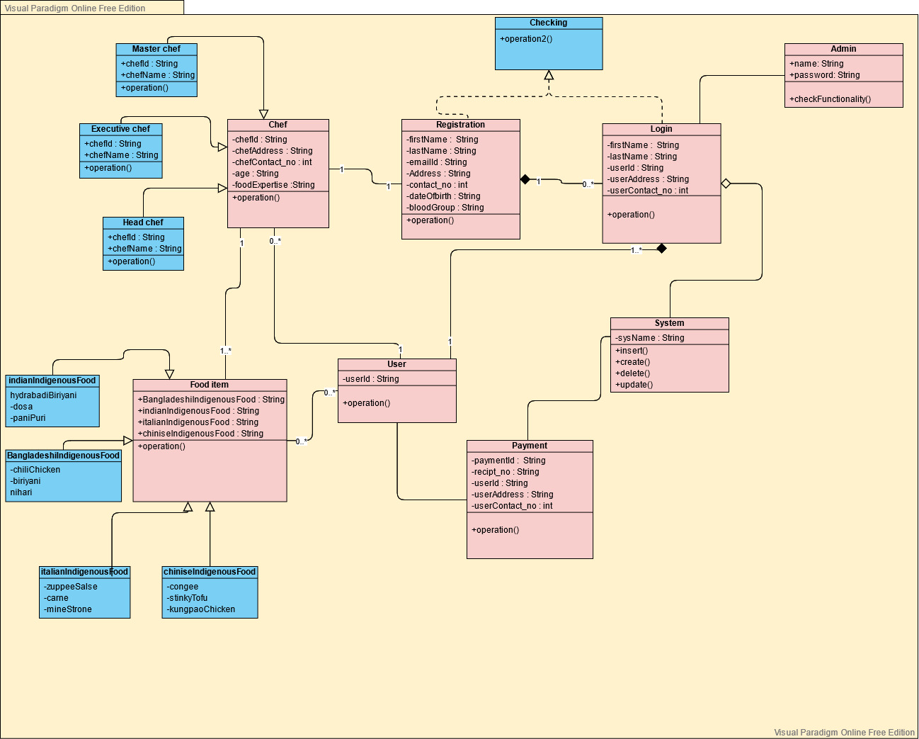

Figure 16: Class diagram of the system

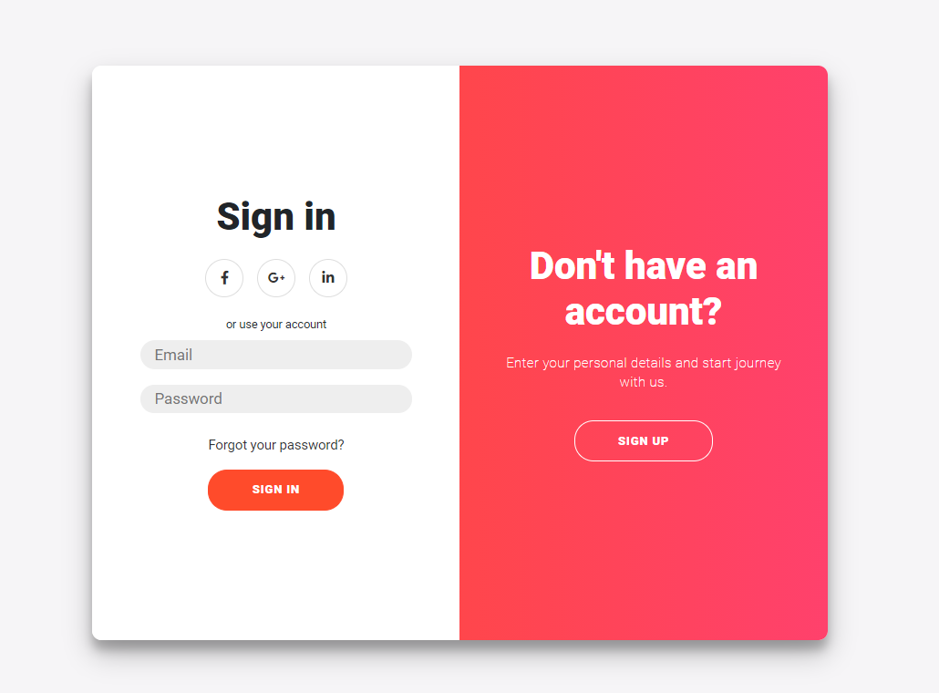

Figure 17: User Login interface

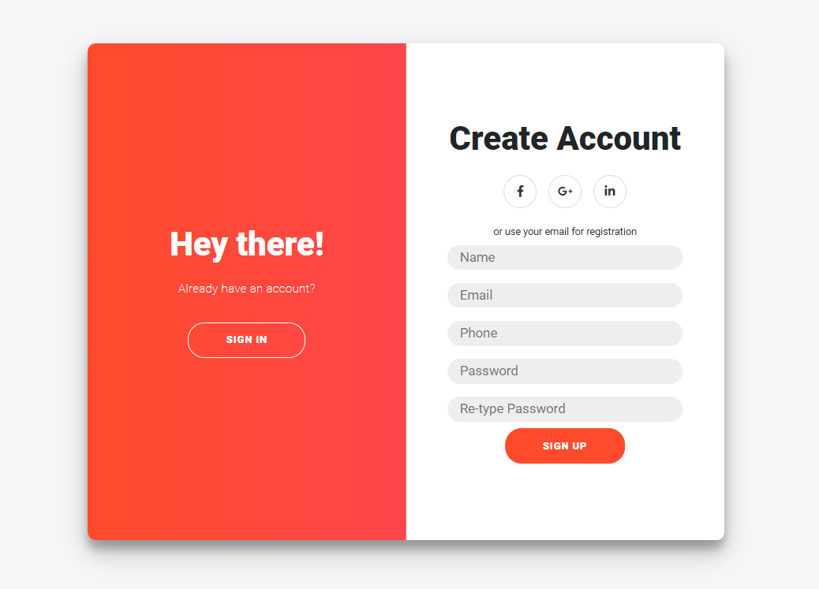

Figure 18: User registration interface

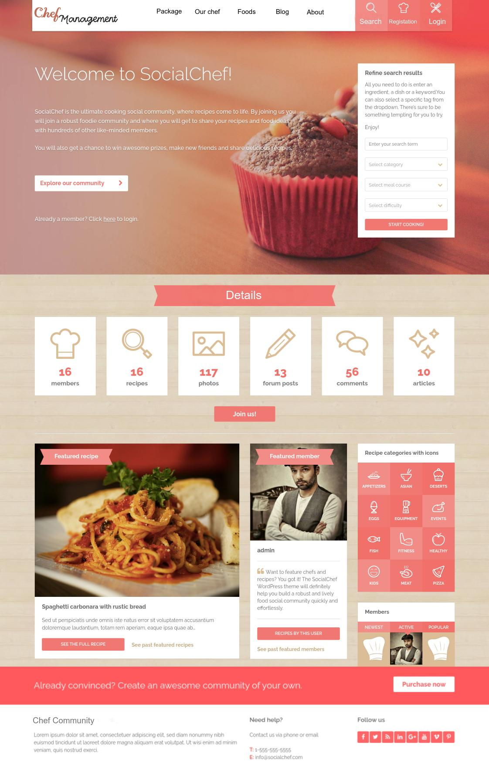

Figure 19: User home page interface

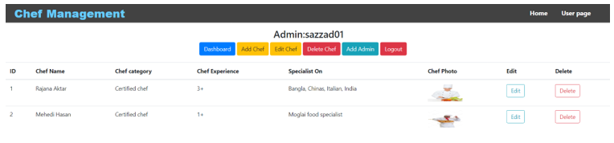

Figure 20: Admin Dashboard interface

# **4.2 Impact on Environment:**

The chef management system is a web-based system. Software has a significant impact on the efficiency and use time of IT hardware resources**.** The Chef Management System has made a significant impact on the environment, some of which are highlighted here

* We are bringing a digital platform to chef management that will eliminate our unemployment.
* Get rid of the amount of food wasted at any one event, food waste will be less.
* Introducing a new system that will benefit the user a lot.
* Using this system will bring economic change in the country.

# **4.3 Lifecycle Analysis**

In this project, four of the project members will be participating and everyone has their own individual role and group task. The moderator of our project will act as the organizer who will keep everyone on task. He will manage the review's pace and serve as a mediator in any disagreements. There will be a reviewer who will be assigned to critical analysis. On the other hand, in this inspection process, a reader will be looking at the source code to present this to the group. The data will not be a critic in this process. This will help separate what the author intended to do and what the actual outcome was. That's how the defects will come out. All the defects found in the source code will be recorded, including the location of the error in the code, wrong pseudo-code, documentation, data usage, developers' errors, designing oversight, and requirements mistakes. All of this information will be kept in a database for deformity measurements. It can be examined from numerous points and perhaps contrasted with comparative measurements from QA (Question Answer).

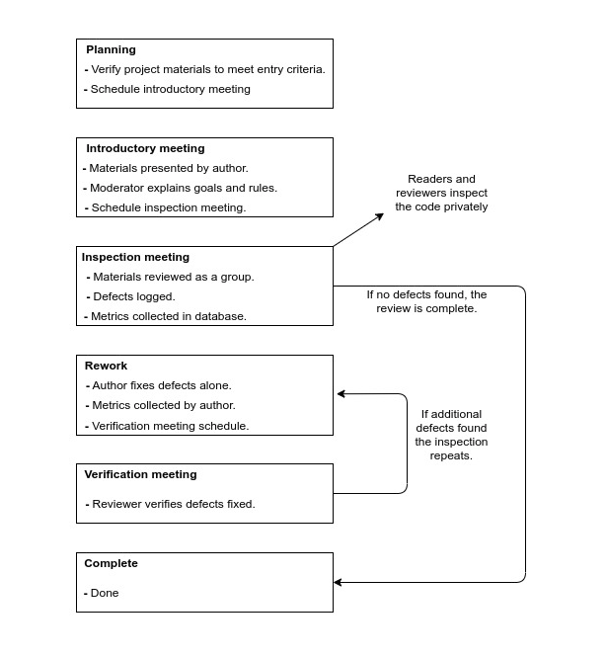

Figure 21: Project lifecycle analysis

# **4.4 Solution Verification**

**Test case of Software Project**

We already know that developing a test plan is the most important task of the test management process. To create a test plan based on IEEE 829, perform the following eight steps:

|  |  |  |  |  |  |
| --- | --- | --- | --- | --- | --- |
| Project Name: Chef Management System | | | Test Designed by:  K.M. Sazzadul Islam | | |
| Test Case ID: FR_1 | | | Test Designed date: 12.10.2021 | | |
| Test Priority (Low, Medium, High): High | | | Test Executed by: Md. Mehedi Hassan Hemal | | |
| Module Name: User Registration Session | | | Test Execution date: 13.08.2021 | | |
| Test Title: verify registration with valid phone number and password. | | |  | | |
| Description: Test web application user registration  page | | |  | | |
| Precondition (If any): User must have valid phone and password | | | | | |
| Test Steps | Test Data | Expected Results | | Actual  Results | Status (Pass/Fail) |
| 1. Go to the website 2. Enter phone number 3. Enter password 4. Re-enter password 5. Click submit | phone number: +880123456789  Password: 321 | User should login into the application  after register into the system | |  |  |
| Post Condition: User is validated with database and successfully login to the account after  successful account creation. The account session details are logged in the database. | | | | | |

|  |  |  |  |  |  |
| --- | --- | --- | --- | --- | --- |
| Project Name: Chef Management System | | | Test Designed by: K.M. Sazzadul Islam | | |
| Test Case ID: FR_2 | | | Test Designed date: 15.10.2021 | | |
| Test Priority (Low, Medium, High): High | | | Test Executed by: Md. Mehedi hassan Hemal | | |
| Module Name: User Login Session | | | Test Execution date: 16.10.2021 | | |
| Test Title: verify login with valid phone number and password | | |  | | |
| Description: Test web application user login page | | |  | | |
| Precondition (If any): User must have valid phone number and password | | | | | |
| Test Steps | Test Data | Expected Results | | Actual Results | Status (Pass/Fail) |
| 1. Go to the website 2. Enter phone number 3. Enter password 4. Click submit | Phone number: +880123456789  Password: 321 | User should login into the application | |  |  |
| Post Condition: User is validated with database and successfully login to account. The account  session details are logged in the database. | | | | | |

|  |  |  |  |  |  |
| --- | --- | --- | --- | --- | --- |
| Project Name: Chef Management System | | | Test Designed by: K.M. Sazzadul Islam | | |
| Test Case ID: FR_3 | | | Test Designed date: 15.11.2021 | | |
| Test Priority (Low, Medium, High): High | | | Test Executed by: Md. Mehedi hassan Hemal | | |
| Module Name: User Login Session | | | Test Execution date: 16.11.2021 | | |
| Test Title: verify login with valid email and password | | |  | | |
| Description: Test web application user login page | | |  | | |
| Precondition (If any): User must have valid email and password | | | | | |
| Test Steps | Test Data | Expected Results | | Actual Results | Status (Pass/Fail) |
| 1. Go to the website 2. Enter email 3. Enter password 4. Click submit | Email: abcxyz@email.com  Password: 321 | User should login into the application | |  |  |
| Post Condition: User is validated with database and successfully login to account. The account  session details are logged in the database. | | | | | |

|  |  |  |  |  |  |
| --- | --- | --- | --- | --- | --- |
| Project Name: Chef Management System | | | Test Designed by: Rajana Akter | | |
| Test Case ID: FR_4 | | | Test Designed date: 19.11.2021 | | |
| Test Priority (Low, Medium, High): High | | | Test Executed by: Salid Shadman | | |
| Module Name: Chef Login Session | | | Test Execution date: 20.11.2021 | | |
| Test Title: verify login with valid phone number and password | | |  | | |
| Description: Test web application chef login page | | |  | | |
| Precondition (If any): User(Chef) must have valid phone number and password | | | | | |
| Test Steps | Test Data | Expected Results | | Actual Results | Status (Pass/Fail) |
| 1. Go to the website 2. Enter phone number 3. Enter password 4. Click submit | phone number: +880123456789  Password: 321 | User(Chef) should login into the application | |  |  |
| Post Condition: User(Chef) is validated with database and successfully login to account. The account session details are logged in the database. | | | | | |

|  |  |  |  |  |  |
| --- | --- | --- | --- | --- | --- |
| Project Name: Chef Management System | | | Test Designed by: Rajana Akter | | |
| Test Case ID: FR_5 | | | Test Designed date: 21.11.2021 | | |
| Test Priority (Low, Medium, High): High | | | Test Executed by: Salid Shadman | | |
| Module Name: Admin Login Session | | | Test Execution date: 22.11.2021 | | |
| Test Title: verify login with valid user_id and password | | |  | | |
| Description: Test web application admin login page | | |  | | |
| Precondition (If any): User(Admin) must have valid user_id and password | | | | | |
| Test Steps | Test Data | Expected Results | | Actual Results | Status (Pass/Fail) |
| 1.Go to the website  2.Enter user_id  3.Enter password  4.Click submit | User_id: admin001  Password: 321 | User(Admin) should login into the application | |  |  |
| Post Condition: User (Admin) is validated with database and successfully login to account. The account session details are logged in the database. | | | | | |

|  |  |  |  |  |  |
| --- | --- | --- | --- | --- | --- |
| Project Name: Chef Management System | | | Test Designed by: Rajana Akter | | |
| Test Case ID: FR_6 | | | Test Designed date: 09.12.2021 | | |
| Test Priority (Low, Medium, High): High | | | Test Executed by: Salid Shadman | | |
| Module Name: Payment Session | | | Test Execution date: 10.12.2021 | | |
| Test Title: verify the payment with valid phone number, amount and password | | |  | | |
| Description: Test website online payment | | |  | | |
| Precondition (If any): User must have a valid account on the system | | | | | |
| Test Steps | Test Data | Expected Results | | Actual Results | Status (Pass/Fail) |
| 1. Click on the payment 2. Enter phone number 3. Enter amount 4. Enter password 5. Click submit | Phone number: +880123456789  Amount: 10000  Password: 321 | Users should able to complete payment session | |  |  |
| Post Condition: User is validated with database and successfully complete payment. The account session details are logged in the database. | | | | | |

|  |  |  |  |  |  |
| --- | --- | --- | --- | --- | --- |
| Project Name: Chef Management System | | | Test Designed by: Rajana Akter | | |
| Test Case ID: FR_7 | | | Test Designed date: 11.12.2021 | | |
| Test Priority (Low, Medium, High): High | | | Test Executed by: Salid Shadman | | |
| Module Name: Search Session | | | Test Execution date: 12.12.2021 | | |
| Test Title: verify search method with valid phone number and password | | |  | | |
| Description: Test website online search | | |  | | |
| Precondition (If any): none | | | | | |
| Test Steps | Test Data | Expected Results | | Actual Results | Status (Pass/Fail) |
| 1. Click on the search icon 2. Enter valid name 3. Click on search | None | Users should able  to search things | |  |  |
| Post Condition: User is complete search successfully. | | | | | |

# **CONCLUSION**

The goal of this project is to develop a chef management system, where people can find a chef. Additionally, we will include some packages with the chef. Our main target is to help people. For the chef management system people easily found the chef for any kind of program or occasion. With this system customers can easily choose their chef with their price range. Our limitation in this project initially launched with a web system. Users can’t pay directly from the website. Our future work is, we will develop this system for android and IOS systems also. We will include a direct payment system. We will add some extra features like an event management system.

Extend your future studies with more explanation

# **REFERENCE**

[1] V. A. Bharadi,(2013) Intelligent e-Restaurant using Android OS, Mumbai.

[2] M. Rajesh,(2015) "E-Restaura+9nt: Online Restaurant Management", *India: International Journal   
 & Magazine of Engineering*.

[3] Khairunnisa K.,September (2009)“The Application of Wireless Food Ordering System”,   
 MASAUM Journal of Computing, Volume 1 Issue 2.

[4] N. a. P. N. a. D. M. a. D. N. Yawale, "A Review Paper on Online Restaurant ManagementSystem".

[5] "smarttechitsolution" . Available: <https://smarttechitsolution.com/index.php/selenium/>.

[6] "geeksforgeeks". Available: <https://www.geeksforgeeks.org/software-engineering-cocomo-model/>.

[7] "scnsoft". Available: <https://www.scnsoft.com/blog/software-development-models#Scrum>.

[8] "TechTarget". Available: <https://searchsoftwarequality.techtarget.com/tip/5-examples-of-ethical-issues-in-software-development>.

[9] "C#corner" [Online]. Available: <https://www.c-sharpcorner.com/article/issues-in-professional-ethics-in-software-project-management/>.

[10] "simplilearn" [Online]. Available: <https://www.simplilearn.com/scrum-project-management-article>

# **APPENDIX**

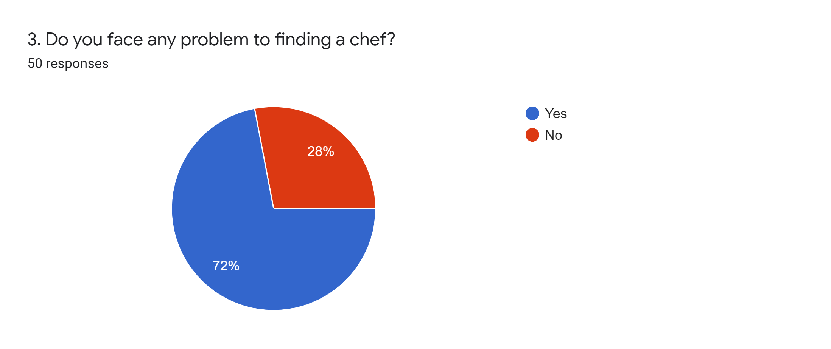

Figure 22: Results of the survey questionaries (1)

**Here 72% of people face problems when they want to find a chef. That's why they want a system where they easily find the chef. So this result tells us this is important for us.**

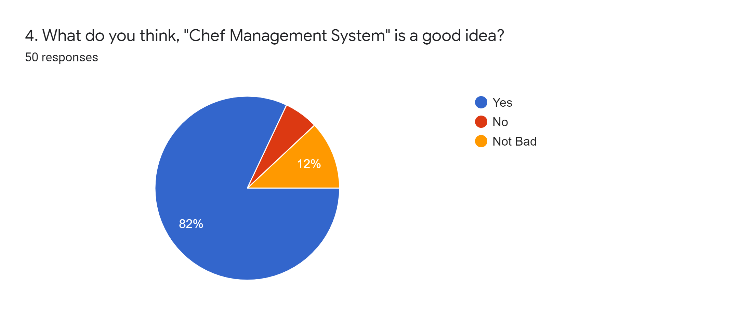

Figure 23: Results of the survey questionaries (2)

**In this question we want to know how many people agree with us to build that type of app. Here we get 82% of people directly agreeing with us and 12% people partially agreeing. So, we will build that type of app very soon for their help.**

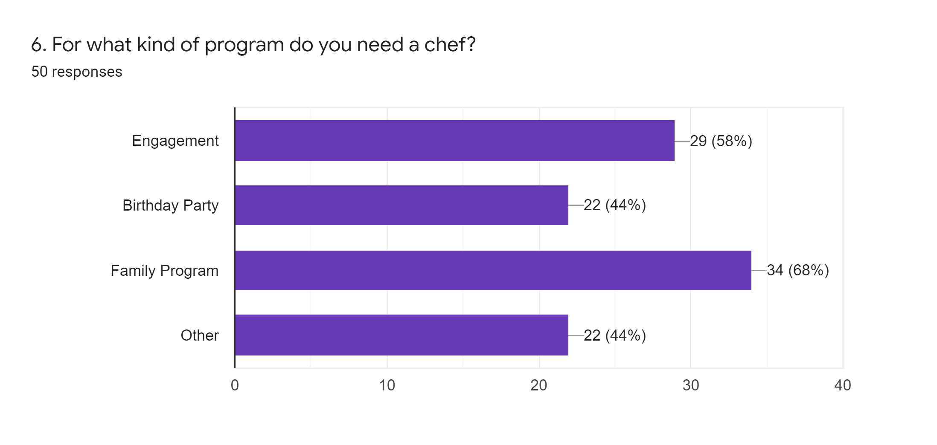

Figure 24: Results of the survey questionaries (3)

**Here we ask people what type of program they arranged and they need a chef. Then we get an idea that different people want a chef for different types of programs. So, we will try to send chefs for all types of programs that they want.**

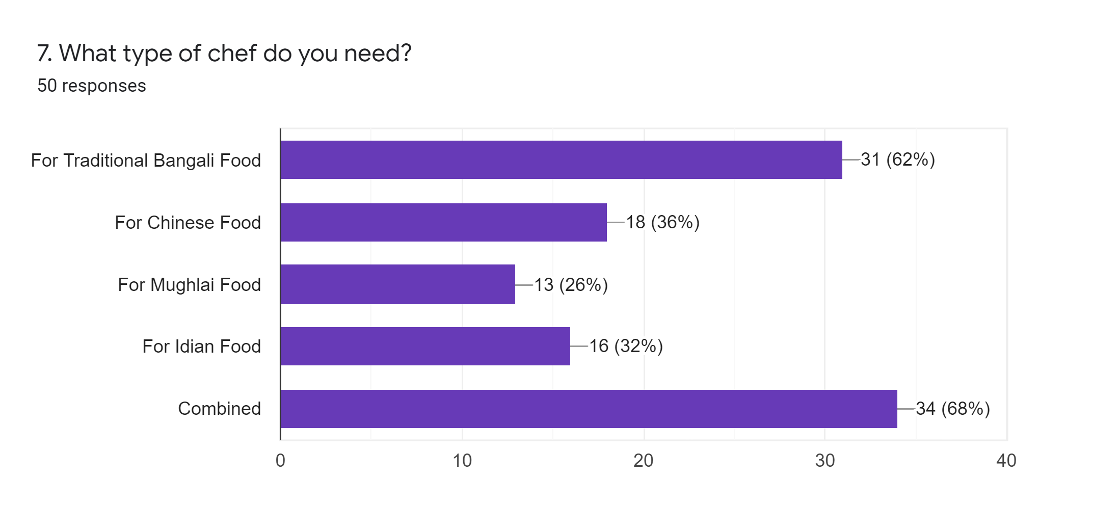

Figure 25: Results of the survey questionaries (4)

**Here we want to know which types of cooking chef people prefer most. We found there near about all types of cooking chefs people want for their program. So, we will try to keep all types of cooking chefs available for their help.**

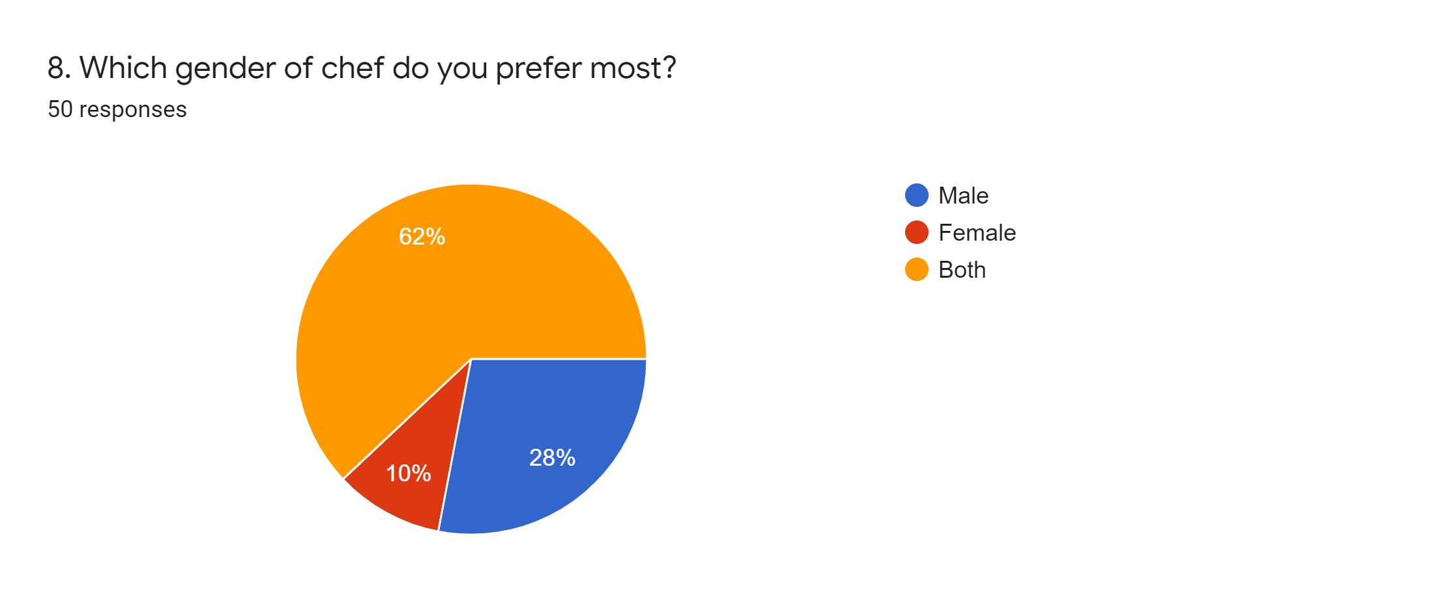

Figure 26: Results of the survey questionaries (5)

**We wanted to confirm through this question that everyone is more willing to take the chef of which gender. Then we get 62% of people want both male and female chefs for their arrangement, 28% of people want only female chefs and 10% of people want only male chefs. So, in this app we will try to keep all options for their help.**

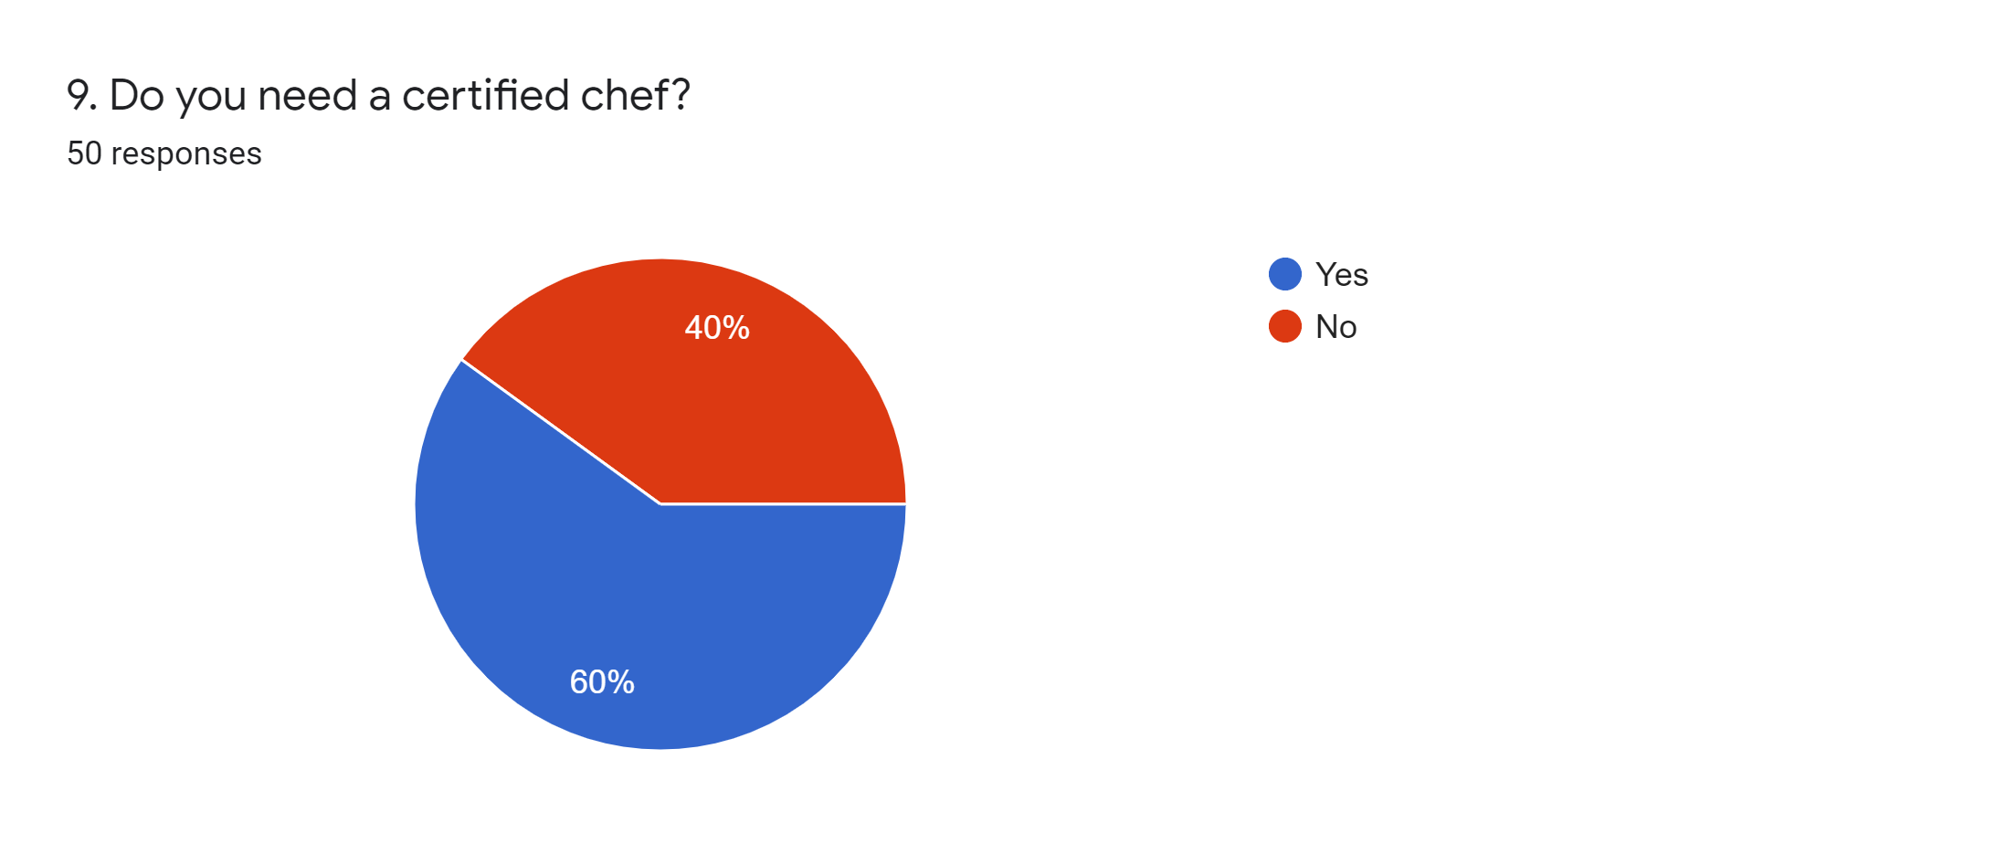

Figure 27: Results of the survey questionaries (26)

**Through this question we want to know if people want a certified chef then we get 60% of people with positive answers and 40% of people with negative answers. So, we will try to keep a certified chef with us.**

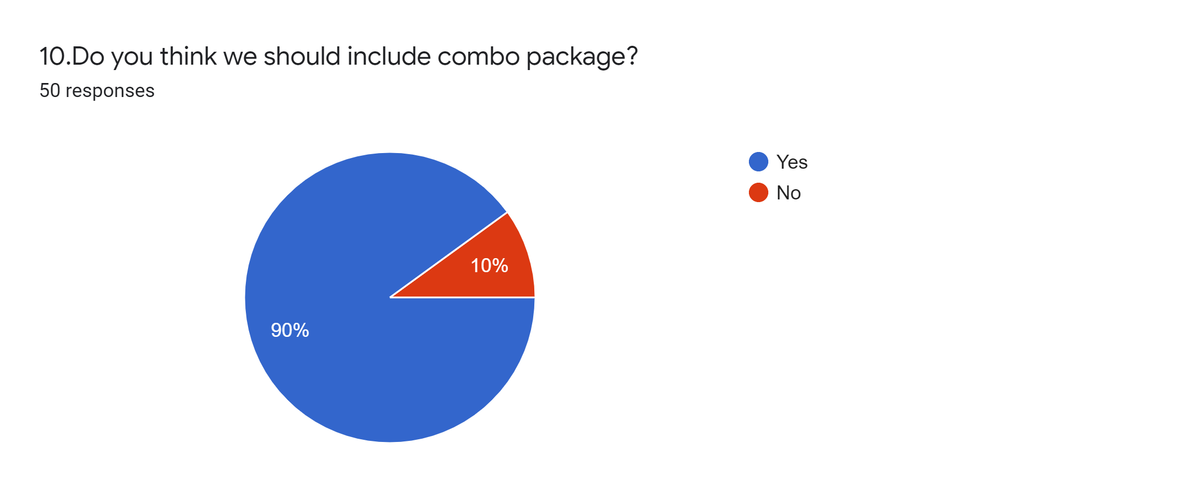

Figure 28: Results of the survey questionaries (27)

**In this question we want to know if the user is willing to take any combo package, here 90% of people respond with yes. So, we will definitely try to arrange the combo package.**

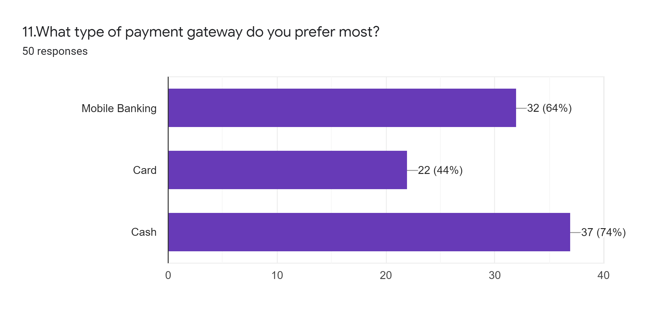

Figure 29: Results of the survey questionaries (28)

**Here we ask the people what types of payment they most prepare, then 74% of people want to pay cash and the rest of the 26% of people choose the other option. So, we will keep in mind all the options available in the payment method.**

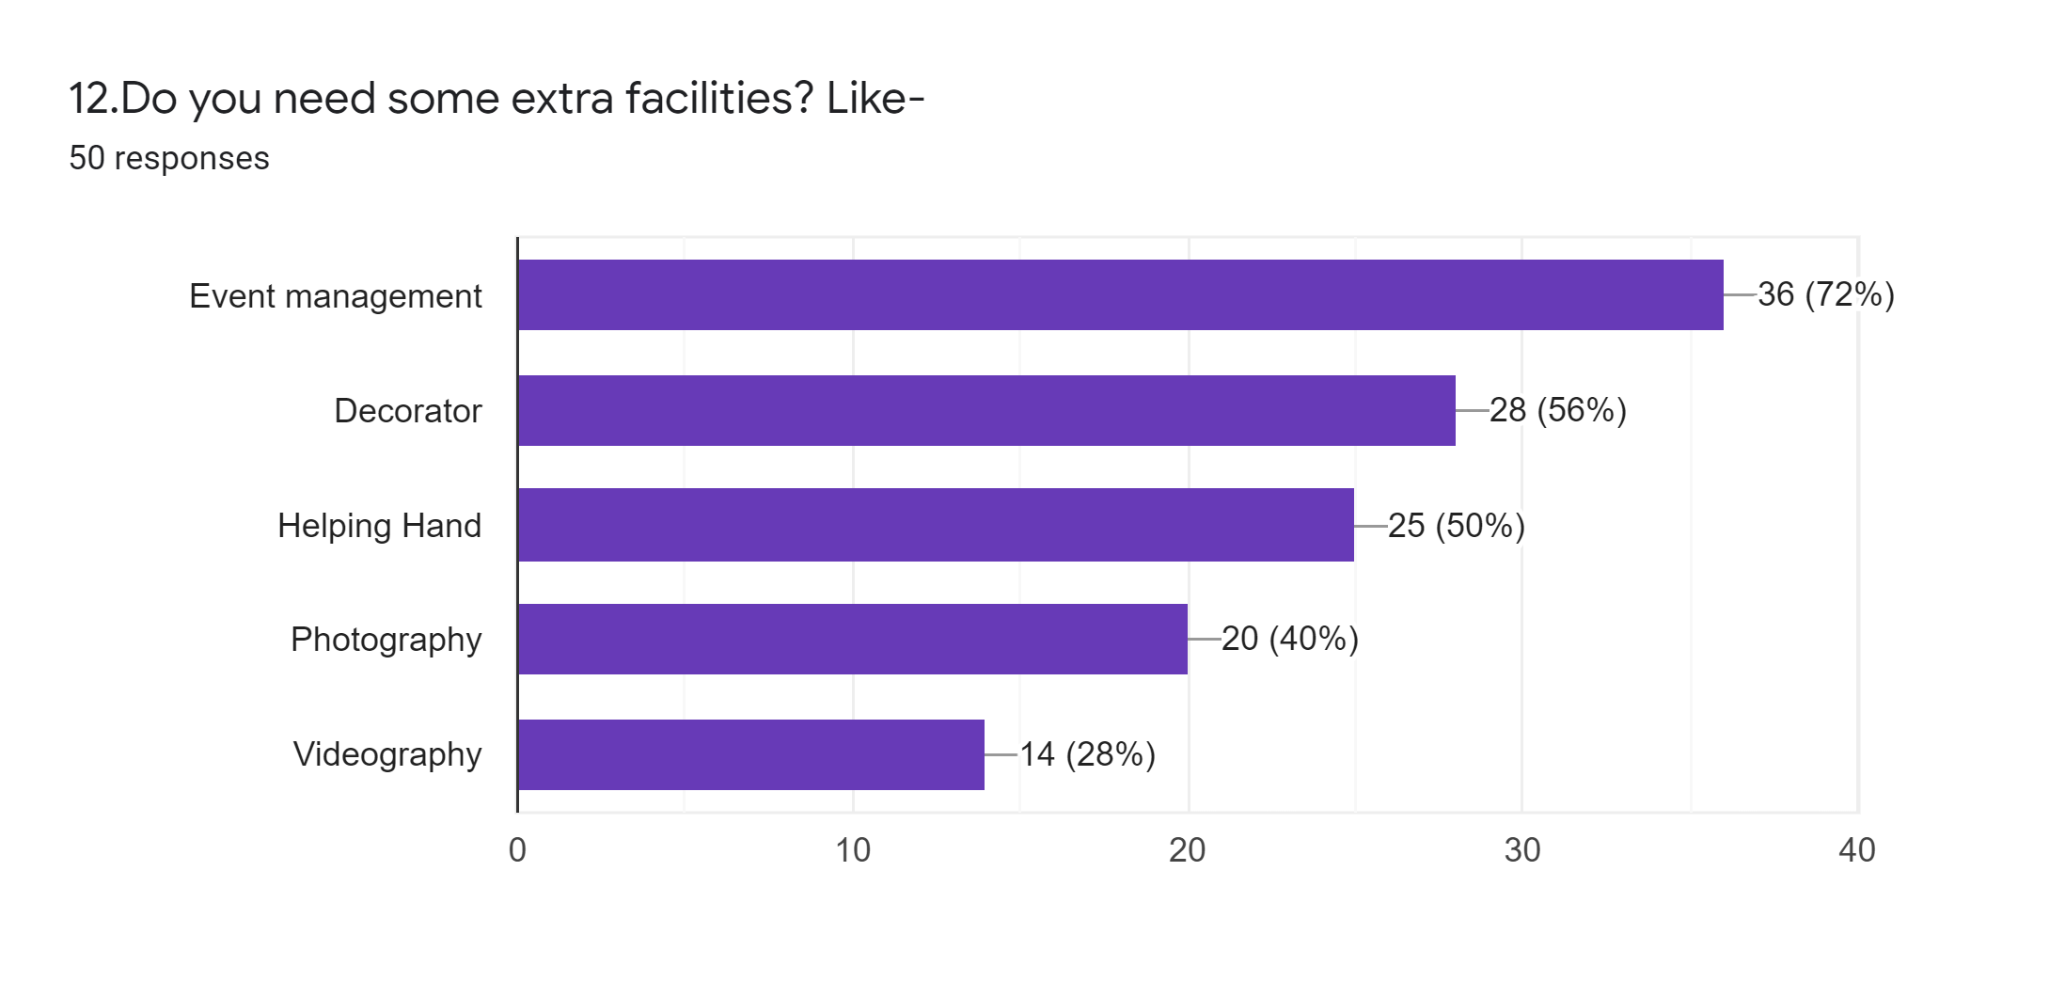

Figure 30: Results of the survey questionaries (29)

**When we ask the people what extra facilities they want to add this app there 72% of people suggest adding “Event management”. So, we will keep this in mind while making the app.**